Thermal Imaging Cameras
Cononley Village Institute, with funding from North Yorkshire Council, have purchased two Flir Thermal Image Cameras. These are helping us to understand where heat and energy is lost from the building and see what improvements can be made to make it more energy efficient. It makes sense to address the fabric of the building, tackle air tightness, ventilation and insulation BEFORE investing in renewable energy.
These thermal imaging cameras available for residents of Cononley to borrow free of charge.
This will enable you to explore ways of making your home more energy efficient and cutting your energy bills.
The camera is easy to use by simply plugging into your mobile phone. We have one device for Apple phones and one for Android phones. The images captured on your mobile phone provide valuable information as to where energy/heat is lost from the building.

How to Apply
Any resident of Cononley can ask to borrow the camera
Email cononleycamera@gmail.com stating if you need the Apple or Android device.
You will receive a reply confirming that you are on the waiting list.
When a camera becomes available you will be contacted, asked to complete a loan form which can be downloaded from cononleyinstitute.co.uk/thermal-imaging and given 24 hours to collect the camera. If you can’t use it on that occasion, just reply and you will stay on the list, but the camera will be offered to someone else.
A period of 5 days is suggested to enable you to carry out your survey. This will depend upon suitable weather conditions.
When you have finished, advise cononleycamera@gmail.com and you will be advised where to return the camera. you will be asked for any relevant feedback to help us improve the scheme.
The camera will be checked so please report any damages or problems. Anyone who loses the camera or fails to return it will be asked to pay for the camera (£300+)
You will be asked for any relevant feedback to help us improve the scheme.
*The Cononley Village Institute Committee and Cleaner Greener Cononley will manage the waiting list, availability and location of the camera.

Disclaimer.
This information sheet is not written by experts but is general information taken from other sources. If any major issues come to light when surveying your property, you may wish to consult an expert before you take any remedial action.
Why Use a Thermal Imaging Camera?
A thermal imaging camera will show you areas of excess heat loss or high moisture content and as such may highlight problems or defects within your property. Some of these may be easily rectifiable, others may be more serious or expensive to rectify. If any major issues come to light when surveying your property, you may wish to consult an expert before you take any remedial action.
Remember older houses were designed to breathe and ventilation bricks are still required to enhance air circulation and prevent condensation.

How to Use the Thermal Imaging Camera.
There must be a temperature difference of at least 5’C between the inside and outside of the property (10’ is better) and should have been so for at least 1 hour for a satisfactory survey. Weather can affect your survey. See “Things to consider when carrying out a survey” on page 4.
- Charge the thermal imaging camera for approximately 40 mins.
- Download the FLIR ONE app from the APP store (it’s free)
- It is best to remove any phone cover. Connect camera to phone, tighten up screw to secure.
- Push on/off button on bottom of camera to turn on. It takes about 20 sec and is ready to use when it flashes green.
- Carry out the external survey first. The image will show white / yellow / red / purple / blue / black. The lighter the colour, the worse the heat loss (so white is worst).
- Carry out the internal survey second, looking at the areas where there is external heat loss. The image will show black / blue / purple / red / yellow / white where there is heat loss (black is worse).
- Once an image is displayed, if you wish, you can tap the arrow at the base of the screen, tap colour palette icon in the lower left and change how the image is displayed. See examples on next page.
http://support.flir.com/resources/6ygz
http://www.flirmedia.com/MMC/THG/Brochures/T820325/T820325_EN.pdf
https://www.flir.co.uk/discover/industrial/picking-a-thermal-color-palette/

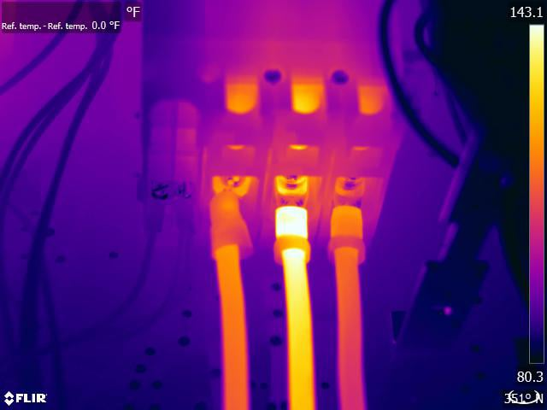
Colour Palettes Available:
IRONBOW:
A favourite among thermographers, Ironbow is a general-purpose palette that quickly identifies thermal anomalies using colour to show heat distribution and subtle details. Hot objects are shown in lighter, warm colours while colder objects are dark, cool colours.

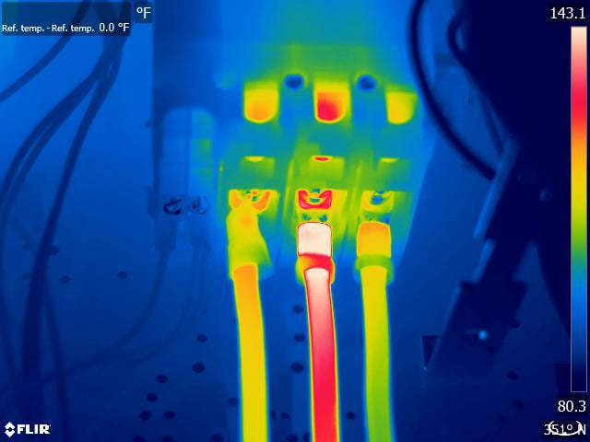

RAINBOW:
Rainbow is like Ironbow with warm colours representing the hottest part of the image and cool colours representing the coldest parts but adds more colours into the mix. It’s good for pinpointing objects in environments with minimal heat differences.

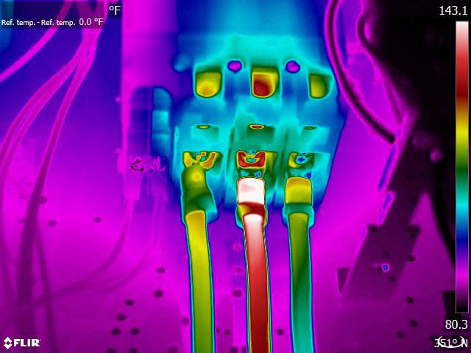

RAINBOW HC:
Rainbow HC, or Rainbow High Contrast, does just what the name says: it adds more contrast to the image. This allows you to see more even detail compared to other palettes and spot subtle temperature differences.
In the winter, purple and dark blue/black ispots inside your home indicate a lack of air sealing or insulation. In the summer, these spots would appear yellow instead.
SPOT METERS. When focussing on one spot, say a window, the FLIR ONE will display a temperature average (in degrees C or F) on the image. The accuracy of the Spot Meter(s) depends on many factors, including the distance from the object, the ambient temperature, and the emissivity of the material being observed.
What Can the Survey Tell Me?
A building diagnostics inspection with a thermal imaging camera can help:
• Visualize energy losses
• Detect missing or defective insulation
• Source air leaks
• Find moisture in insulation, in roofs and walls, both in the internal and the external structure
• Detect mould and badly insulated areas
• Locate thermal bridges
• Locate water infiltration in flat roofs
• Detect breaches in hot-water pipes
• Detect construction failures
• Monitor the drying of buildings
• Find faults in supply lines and district heating
• Detect electrical faults

Things to consider when carrying out a survey
Some materials, such as most metals, reflect thermal radiation, much like a mirror reflects visible light. Reflections can lead to misinterpretation of the thermal image; the reflection of thermal radiation from the operator’s own body or from a light bulb might lead to a false temperature reading. The operator should therefore choose the angle at which the thermal imaging camera is pointed at the object carefully, to avoid such reflections.

Influences on the outside of a building. It probably goes without saying that direct sunlight can influence thermal readings, but sunlight can have long lasting effects as well. Direct sunlight and shadows might even influence the thermal pattern on a surface many hours after the exposure to sunlight has ended. Differences in thermal conductivity can also cause differences in thermal patterns. Brick changes temperature much slower than wood, for example. Wind can also influence the thermal data. Airflows cool down the surface material, lowering the temperature differences between hot and cold areas. Another obvious factor that can render thermal imaging inspection useless is rain since it lowers the surface temperatures. Even after the rain has stopped the evaporation of the water cools down the material’s surface. Obviously, this can lead to misleading thermal patterns.

Influences on the inside of the building. Bookshelves, cabinets and pictures hanging on the wall can also change the thermal pattern. These examples of furniture and wall decorations have an insulating effect. If these things are taken away from the wall, that area of the wall will show up in the thermal image as being colder. This might be confused for missing insulation. For that reason, it is advisable to remove items from the wall at least 6 hours before inspection.
Reflections from the surroundings. When scanning reflective targets, be sure to change your angle to minimize the reflections on the image. The reflection could be from your body heat, or some other heat source in the area, a piece of machinery, light bulb or a transformer. Reflections will give you incorrect data in the thermal image, and if not understood, it is a data error.

